Trinity: Centre Policy
GCSEs for summer 2021

Centre Policy for determining teacher assessed grades – summer 2021:
Trinity Church of England School, Lewisham

Statement of intent
This section outlines the purpose of this document in relation to our centre.

Statement of Intent
This section provides details of the purpose of this document, as appropriate to our centre:

The purpose of this policy is:
- To ensure that teacher assessed grades are determined fairly, consistently, free from bias and effectively within and across departments.
- To ensure the operation of effective processes with clear guidelines and support for staff.
- To ensure that all staff involved in the processes clearly understand their roles and responsibilities.
- To support teachers to take evidence-based decisions in line with Joint Council for Qualifications guidance.
- To ensure the consideration of historical centre data in the process, and the appropriate decision making in respect of, teacher assessed grades.
- To support a high standard of internal quality assurance in the allocation of teacher assessed grades.
- To support our centre in meeting its obligations in relation to equality legislation.
- To ensure our centre meets all requirements set out by the Department of Education, Ofqual, the Joint Council for Qualifications and awarding organisations for Summer 2021 qualifications.
- To ensure the process for communicating to candidates and their parents/carers how they will be assessed is clear, in order to give confidence.

Roles and responsibilities
This section of our Centre Policy outlines the personnel in our centre who have specific roles and responsibilities in the process of determining teacher assessed grades this year.

Roles and Responsibilities
This section gives details of the roles and responsibilities within our centre:

Head of Centre
- Our Head of Centre, David Lucas, will be responsible for approving our policy for determining teacher assessed grades.
- Our Head of Centre has overall responsibility for the school as an examinations centre and will ensure that clear roles and responsibilities of all staff are defined.
- Our Head of Centre will confirm that teacher assessed grade decisions represent the academic judgement made by teachers and that the checks in place ensure these align with the guidance on standards provided by awarding organisations.
- Our Head of Centre will ensure a robust internal quality assurance process has been produced and signed-off in advance of results being submitted.

Senior Leadership Team and Heads of Department
Our Senior Leadership Team and Heads of Departments will:
- provide training and support to our other staff.
- support the Head of Centre in the quality assurance of the final teacher assessed grades.
- ensure an effective approach within and across departments and authenticating the preliminary outcome from single teacher subjects.
- be responsible for ensuring staff have a clear understanding of the internal and external quality assurance processes and their role within it.
- ensure that all teachers within their department make consistent judgements about student evidence in deriving a grade.
- ensure all staff conduct assessments under the appropriate levels of control with reference to guidance provided by the Joint Council for Qualifications.
- ensure teachers have the information required to make accurate and fair judgments.
- ensure that a Head of Department Checklist is completed for each qualification that they are submitting.

Teachers/ Specialist Teachers / SENCo
Our teachers, specialist teachers and SENCo will:
- ensure they conduct assessments under our centre’s appropriate levels of control and have sufficient evidence, in line with this Centre Policy and guidance from the Joint Council for Qualifications, to provide teacher assessed grades for each student they have entered for a qualification.
- ensure that the teacher assessed grade they assign to each student is a fair, valid and reliable reflection of the assessed evidence available for each student.
- make judgements based on what each student has been taught and what they have been assessed on, as outlined in the section on grading in the main JCQ guidance.
- produce an Assessment Record for each subject cohort, that includes the nature of the assessment evidence being used, the level of control for assessments considered, and any other evidence that explains the determination of the final teacher assessed grades. Any necessary variations for individual students will also be recorded.
- securely store and be able to retrieve sufficient evidence to justify their decisions.

Examinations Officer
Our Examinations Officer will:
- be responsible for the administration of our final teacher assessed grades and for managing the post-results services.

Training, support and guidance
This section of our Centre Policy outlines the training, support and guidance that our centre will provide to those determining teacher assessed grades this year.

Training
This section provides details of the approach our centre will take to training, support and guidance in determining teacher assessed grades this year

- Teachers involved in determining grades in our centre will attend any centre-based training to help achieve consistency and fairness to all students. This will form the basis of SLT meetings and middle leader / subject leader meetings where specific guidance is given to ensure the practice is consistent across the school.
- Teachers will engage fully with all training and support that has been provided by the Joint Council for Qualifications and the awarding organisations.

Support for Newly Qualified Teachers and teachers less familiar with assessment
This section provides details of our approach to training, support and guidance for newly qualified teachers and teachers less familiar with assessment

- We will provide mentoring from experienced teachers to NQTs and teachers less familiar with assessment.
- We will put in place additional internal reviews of teacher assessed grades for NQTs and other teachers as appropriate.

Use of appropriate evidence
This section of our Centre Policy indicates how our centre will give due regard to the section in the JCQ guidance entitled: Guidance on grading for teachers.

- Use of evidence
This section gives details in relation to our use of evidence.

- Teachers making judgements will have regard to the Ofqual Head of Centre guidance on recommended evidence, and further guidance provided by awarding organisations.
- All candidate evidence used to determine teacher assessed grades, and associated documentation, will be retained and made available for the purposes of external quality assurance and appeals.
- We will be using student work produced in response to assessment materials provided by our awarding organisation(s), including groups of questions, past papers or similar materials such as practice or sample papers.
- We will use non-exam assessment work (often referred to as coursework), even if this has not been fully completed.
- We will use student work produced in centre-devised tasks that reflect the specification, that follow the same format as awarding organisation materials, and have been marked in a way that reflects awarding organisation mark schemes.
- We will use substantial class or homework (including work that took place during remote learning).
- We will use internal tests taken by pupils.
- We will use mock exams taken over the course of study.
- We will use records of a student’s capability and performance over the course of study in performance-based subjects such as music, drama and PE.

We provide further detail in the following areas:

Additional Assessment Materials
- We will use additional assessment materials to give students the opportunity to show what they know, understand or can do in an area of content that has been taught but not yet assessed.
- We will use additional assessment materials to give students an opportunity to show improvement, for example, to validate or replace an existing piece of evidence.
- We will use additional assessment materials to support consistency of judgement between teachers or classes by giving everyone the same task to complete.
- We will combine and/or remove elements of questions where, for example, a multi-part question includes a part which focuses on an element of the specification that hasn’t been taught.
Our centre will ensure the appropriateness of evidence and balance of evidence in arriving at grades in the following ways:

- We will consider the level of control under which an assessment was completed, for example, whether the evidence was produced under high control and under supervision or at home.
- We will ensure that we are able to authenticate the work as the student’s own, especially where that work was not completed within the school or college.
- We will consider the limitations of assessing a student’s performance when using assessments that have been completed more than once, or drafted and redrafted, where this is not a skill being assessed.
- We will consider the specification and assessment objective coverage of the assessment.
- We will consider the depth and breadth of knowledge, understanding and skills assessed, especially higher order skills within individual assessments.

Determining teacher assessed grades
This section of our Centre Policy outlines the approach our centre will take to awarding teacher assessed grades.

Awarding teacher assessed grades based on evidence
We give details here of our centre’s approach to awarding teacher assessed grades.

- Our teachers will determine grades based on evidence which is commensurate with the standard at which a student is performing, i.e. their demonstrated knowledge, understanding and skills across the content of the course they have been taught.
- Our teachers will record how the evidence was used to arrive at a fair and objective grade, which is free from bias.
- Our teachers will produce an Assessment Record for each subject cohort and will share this with their Head of Department. Any necessary variations for individual students will also be shared.

Internal quality assurance
This section of our Centre Policy outlines the approach our centre will take to ensure internal standardisation of teacher assessed grades, to ensure consistency, fairness and objectivity of decisions.

Head of Centre Internal Quality Assurance and Declaration

Internal quality assurance
This section gives details of our approach to internal standardisation, within and across subject departments.

- We will ensure that all teachers involved in deriving teacher assessed grades read and understand this Centre Policy document.
- In subjects where there is more than one teacher and/or class in the department, we will ensure that our centre carries out an internal standardisation process.
- We will ensure that all teachers are provided with training and support to ensure they take a consistent approach to:
- Arriving at teacher assessed grades
- Marking of evidence
- Reaching a holistic grading decision
- Applying the use of grading support and documentation
- We will conduct internal standardisation across all grades.
- We will ensure that the Assessment Record will form the basis of internal standardisation and discussions across teachers to agree the awarding of teacher assessed grades.
- Where necessary, we will review and reflect on individual grading decisions to ensure alignment with the standards as outlined by our awarding organisation(s).
- Where appropriate, we will amend individual grade decisions to ensure alignment with the standards as outlined by our awarding organisation(s).
- Where there is only one teacher involved in marking assessments and determining grades, then the output of this activity will be reviewed by an appropriate member of staff within the centre.
- This will be the line leader of that subject who is a member of the SLT.
- In respect of equality legislation, we will consider the range of evidence for students of different protected characteristics that are included in our internal standardisation.

Comparison of teacher assessed grades to results for previous cohorts
This section of our Centre Policy outlines the approach we will take to compare our teacher assessed grades in 2021 with results from previous cohorts.

Comparison of Teacher Assessed Grades to results for previous cohorts
This section gives details of our internal process to ensure a comparison of teacher assessed grades at qualification level to results for previous cohorts in our centre taking the same qualification.

- We will compile information on the grades awarded to our students in past June series in which exams took place (e.g. 2017 - 2019).
- We will consider the size of our cohort from year to year.
- We will consider the stability of our centre’s overall grade outcomes from year to year.
- We will consider both subject and centre level variation in our outcomes during the internal quality assurance process.
- We will prepare a succinct narrative on the outcomes of the review against historic data which, in the event of significant divergence from the qualifications-levels profiles attained in previous examined years, which address the reasons for this divergence. This commentary will be available for subsequent review during the QA process.

This section gives details of the approach our centre will follow if our initial teacher assessed grades for a qualification are viewed as overly lenient or harsh compared to results in previous years.

- We will compile historical data giving appropriate regard to potential mixtures of A*-G and 9-1 grades in GCSEs. Where required, we will use the Ofqual guidance to convert legacy grades into the new 9 to 1 scale.
- We will include grades from international GCSEs (for example, in mathematics) because we have previously offered these.
- We will bring together other data sources that will help to quality assure the grades we intend to award in 2021.
This section gives details of changes in our cohorts that need to be reflected in our comparisons.

- We will omit subjects that we no longer offer from the historical data.
- We will look at national trends in subjects that are new courses that we are offering or ones that we are only in the second year of delivery.

Access Arrangements and Special Considerations
This section of our Centre Policy outlines the approach our centre will take to provide students with appropriate access arrangements and take into account mitigating circumstances in particular instances.

Reasonable adjustments and mitigating circumstances (special consideration)
This section gives details of our approach to access arrangements and mitigating circumstances (special consideration).

- Where students have agreed access arrangements or reasonable adjustments (for example a reader or scribe) we will make every effort to ensure that these arrangements are in place when assessments are being taken.
- Where an assessment has taken place without an agreed reasonable adjustment or access arrangement, we will remove that assessment from the basket of evidence and alternative evidence obtained.
- Where illness or other personal circumstances might have affected performance in assessments used in determining a student’s standard of performance, we will take account of this when making judgements.
- We will record, as part of the Assessment Record, how we have incorporated any necessary variations to take account of the impact of illness or personal circumstances on the performance of individual students in assessments.
- To ensure consistency in the application of Special Consideration, we will ensure all teachers have read and understood the document: JCQ – A guide to the special consideration process, with effect from 1 September 2020

Addressing disruption/differential lost learning (DLL)

- Addressing Disruption/Differentiated Lost Learning (DLL)
This section gives details of our approach to address disruption or differentiated lost teaching.

- Teacher assessed grades will be determined based on evidence of the content that has been taught and assessed for each student.

Objectivity
This section of our Centre Policy outlines the arrangements in place to ensure objectivity of decisions.
Objectivity
This section gives a summary of the arrangements in place within our centre in relation to objectivity.

Staff will fulfil their duties and responsibilities in relation to relevant equality and disability legislation.

Senior Leaders, Heads of Department and Centre will consider:
- sources of unfairness and bias (situations/contexts, difficulty, presentation and format, language, conditions for assessment, marker preconceptions);
- how to minimise bias in questions and marking and hidden forms of bias); and
- bias in teacher assessed grades.

To ensure objectivity, all staff involved in determining teacher assessed grades will be made aware that:
- unconscious bias can skew judgements;
- the evidence presented should be valued for its own merit as an indication of performance and attainment;
- teacher assessed grades should not be influenced by candidates’ positive or challenging personal circumstances, character, behaviour, appearance, socio-economic background, or protected characteristics;
- unconscious bias is more likely to occur when quick opinions are formed; and

Our internal standardisation process will help to ensure that there are different perspectives to the quality assurance process.

Recording decisions and retention of evidence and data
This section of our Centre Policy outlines our arrangements to recording decisions and to retaining evidence and data.
- Recording Decisions and Retention of Evidence and Data
This section outlines our approach to recording decisions and retaining evidence and data.

- We will ensure that teachers and Heads of Departments maintain records that show how the teacher assessed grades process operated, including the rationale for decisions in relation to individual marks/grades.
- We will ensure that evidence is maintained across a variety of tasks to develop a holistic view of each student’s demonstrated knowledge, understanding and skills in the areas of content taught.
- We will put in place recording requirements for the various stages of the process to ensure the accurate and secure retention of the evidence used to make decisions.
- We will comply with our obligations regarding data protection legislation.
- We will ensure that the grades accurately reflect the evidence submitted.
- We will ensure that evidence is retained electronically or on paper in a secure centre-based system that can be readily shared with our awarding organisation(s).

Authenticating evidence

- Authenticating evidence
This section of our Centre Policy details the mechanisms in place to ensure that teachers are confident in the authenticity of evidence, and the process for dealing with cases where evidence is not thought to be authentic.

- Robust mechanisms, which will include pupil and parent declaration forms, will be in place to ensure that teachers are confident that work used as evidence is the students’ own and that no inappropriate levels of support have been given to students to complete it, either within the centre or with external tutors.
- It is understood that awarding organisations will investigate instances where it appears evidence is not authentic. We will follow all guidance provided by awarding organisations to support these determinations of authenticity.

Confidentiality, malpractice and conflicts of interest

Confidentiality
This section of our Centre Policy outlines the measures in place to ensure the confidentiality of the grades our centre determines, and to make students aware of the range of evidence on which those grades will be based.

- Confidentiality
This section details the measures in place in our centre to maintain the confidentiality of grades, while sharing information regarding the range of evidence on which the grades will be based.

- All staff involved have been made aware of the need to maintain the confidentiality of teacher assessed grades.
- All teaching staff have been briefed on the requirement to share details of the range of evidence on which students’ grades will be based, while ensuring that details of the final grades remain confidential.
- Relevant details from this Policy, including requirements around sharing details of evidence and the confidentiality requirements, have been shared with parents/guardians.

Malpractice
This section of our Centre Policy outlines the measures in place to prevent malpractice and other breaches of exam regulations, and to deal with such cases if they occur.
- Malpractice
This section details the measures in place in our centre to prevent malpractice and, where that proves impossible, to handle cases in accordance with awarding organisation requirements.

- Our general centre policies regarding malpractice, maladministration and conflicts of interest have been reviewed to ensure they address the specific challenges of delivery in Summer 2021.
- All staff involved have been made aware of these policies, and have received training in them as necessary.
- All staff involved have been made aware of the specific types of malpractice which may affect the Summer 2021 series including:
- breaches of internal security;
- deception;
- improper assistance to students;
- failure to appropriately authenticate a student’s work;
- over direction of students in preparation for common assessments;
- allegations that centres submit grades not supported by evidence that they know to be inaccurate;
- centres enter students who were not originally intending to certificate a grade in the Summer 2021 series;
- failure to engage as requested with awarding organisations during the External Quality Assurance and appeal stages; and
- failure to keep appropriate records of decisions made and teacher assessed grades.

- The consequences of malpractice or maladministration as published in the JCQ guidance: JCQ Suspected Malpractice: Policies and Procedures and including the risk of a delay to students receiving their grades, up to, and including, removal of centre status have been outlined to all relevant staff.

Conflicts of Interest
This section of our Centre Policy outlines the measures in place to address potential conflicts of interest.
- Conflicts of Interest
This section details our approach to addressing conflicts of interest, and how we will respond to such allegations.

- To protect the integrity of assessments, all staff involved in the determination of grades must declare any conflict of interest such as relationships with students to our Head of Centre for further consideration.
- Our Head of Centre will take appropriate action to manage any conflicts of interest arising with centre staff in accordance with the JCQ documents - General Regulations for Approved Centres, 1 September 2020 to 31 August 2021.
- We will also carefully consider the need if to separate duties and personnel to ensure fairness in later process reviews and appeals.

External Quality Assurance
This section of our Centre Policy outlines the arrangements in place to comply with awarding organisation arrangements for External Quality Assurance of teacher assessed grades in a timely and effective way.

- External Quality Assurance
This section outlines the arrangements we have in place to ensure the relevant documentation and assessment evidence can be provided in a timely manner for the purposes of External Quality Assurance sampling, and that staff can be made available to respond to enquiries.

- All staff involved have been made aware of the awarding organisation requirements for External Quality Assurance as set out in the JCQ Guidance.
- All necessary records of decision-making in relation to determining grades have been properly kept and can be made available for review as required.
- All student evidence on which decisions regarding the determination of grades has been retained and can be made available for review as required.
- Instances where student evidence used to decide teacher assessed grades is not available, for example where the material has previously been returned to students and cannot now be retrieved, will be clearly recorded on the appropriate documentation.
- All staff involved have been briefed on the possibility of interaction with awarding organisations during the different stages of the External Quality Assurance process and can respond promptly and fully to enquiries, including attendance at Virtual Visits should this prove necessary.
- Arrangements are in place to respond fully and promptly to any additional requirements/reviews that may be identified as a result of the External Quality Assurance process.
- Staff have been made aware that a failure to respond fully and effectively to such additional requirements may result in further action by the awarding organisations, including the withholding of results.

Results
This section of our Centre Policy outlines our approach to the receipt and issue of results to students and the provision of necessary advice and guidance.

- Results
This section details our approach to the issue of results to students and the provision of advice and guidance.

- All staff involved have been made aware of the specific arrangements for the issue of results in Summer 2021.
- Arrangements will be made to ensure the necessary staffing, including exams office and support staff, to enable the efficient receipt and release of results to our students.
- Arrangements will be in place for the provision of all necessary advice, guidance and support, including pastoral support, to students on receipt of their results.
- Such guidance will include advice on the appeals process in place in 2021 (see below).
- Appropriate staff will be available to respond promptly to any requests for information from awarding organisations, for example regarding missing or incomplete results, to enable such issues to be swiftly resolved.
- Parents/guardians have been made aware of arrangements for results days.

Appeals
This section of our Centre Policy outlines our approach to Appeals, to ensure that they are handled swiftly and effectively, and in line with JCQ requirements.

- Appeals
This section details our approach to managing appeals, including Centre Reviews, and subsequent appeals to awarding organisations.

- All staff involved have been made aware of the arrangements for, and the requirements of, appeals in Summer 2021, as set out in the JCQ Guidance.
- Internal arrangements will be in place for the swift and effective handling of Centre Reviews in compliance with the requirements.
- All necessary staff have been briefed on the process for, and timing of, such reviews, and will be available to ensure their prompt and efficient handling.
- Leaners have been appropriately guided as to the necessary stages of appeal.
- Arrangements will be in place for the timely submission of appeals to awarding organisations, including any priority appeals, for example those on which university places depend.
- Arrangements will be in place to obtain the written consent of students to the initiation of appeals, and to record their awareness that grades may go down as well as up on appeal.
- Appropriate information on the appeals process will be provided to parents/carers.

Appendix A

Trinity Church of England School – Whole school systems for awarding GCSE grades in 2021

Process of grade setting / moderation in 2021
Trinity School set up a comprehensive processes for setting grades in 2021 that was transparent to all stakeholders and ensured teachers used the most up to date accurate information that the pupils completed. A system for setting regular assessments showing curriculum coverage was clearly communicated and centrally tracked to gather evidence for grading. This along with assessments from across KS4 were to be used and parents kept informed if their current performance was seeing a change in their grade through engagement trackers. This system is highlighted in the flow diagram below.

Data to be used for final decisions:
- End of year 9 final assessment – set as full exam using exam board material and mark scheme
- End of year 10 final assessment – which was on average 2 papers for each subject, repeating work from year 9 and all learnt in year 10 as well.
- November of year 11 mock internal exams – which included work from the whole of year 9, 10 and up until Christmas.
- 8 assessment opportunities every fortnight from January to the end of May
- FFT predicted grades based on national data and prior attainment
- FFT Benchmarking service – which is a national provision to enable comparison of pupil outcomes based on prior attainment
- We use an external data company that will be using our data and our own schools prior attainment over the last 3 years to give data on pupil performance based on historical data
- Moderation meetings within departments have occurred after each of the assessments indicated above
- Whole school moderation twice using the data and Senior Leadership Team

Whole school quality assurance

Communications with parents & pupils JANUARY 2021
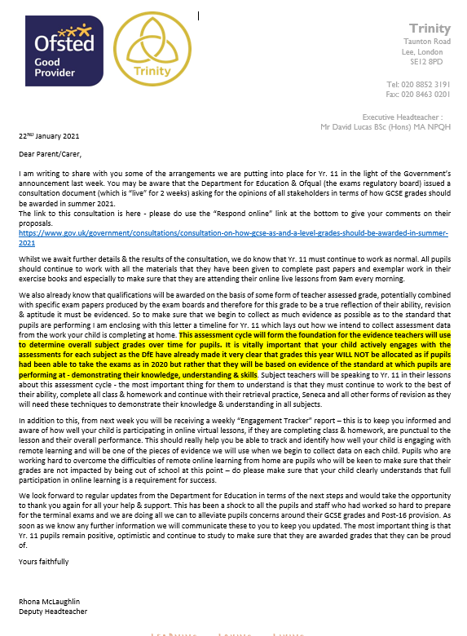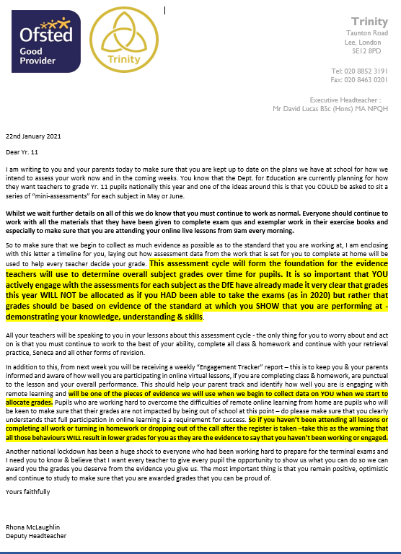

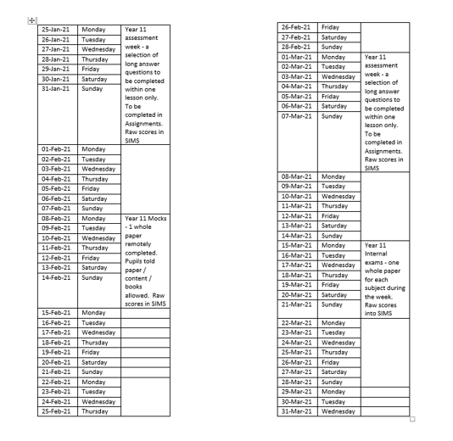

Fortnightly Whole School Assessment Cycle
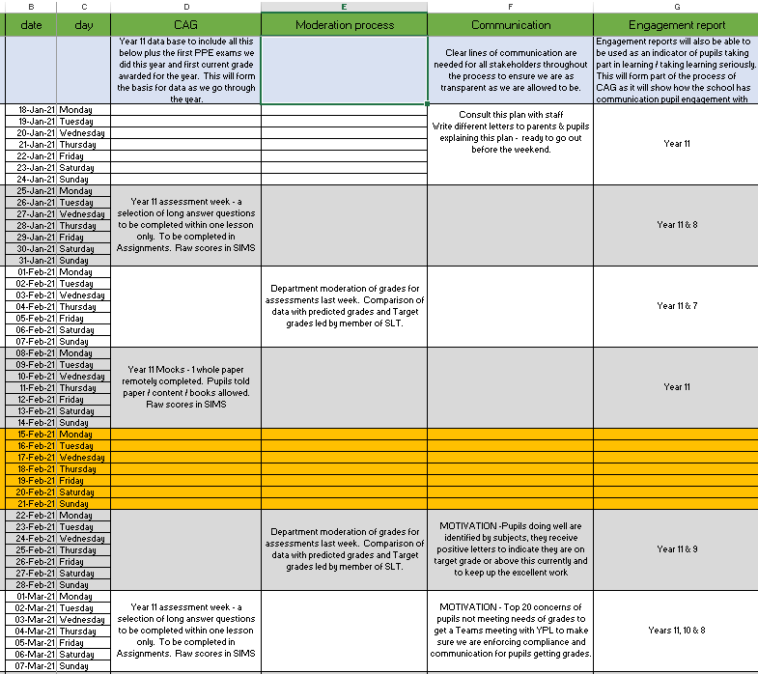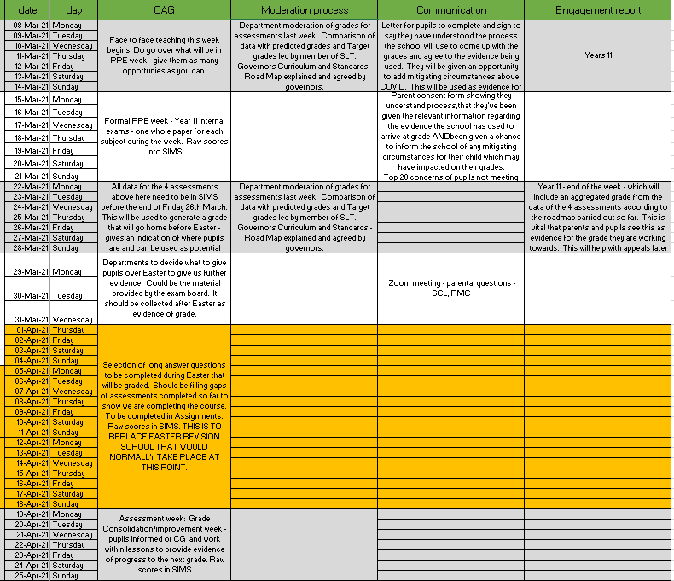
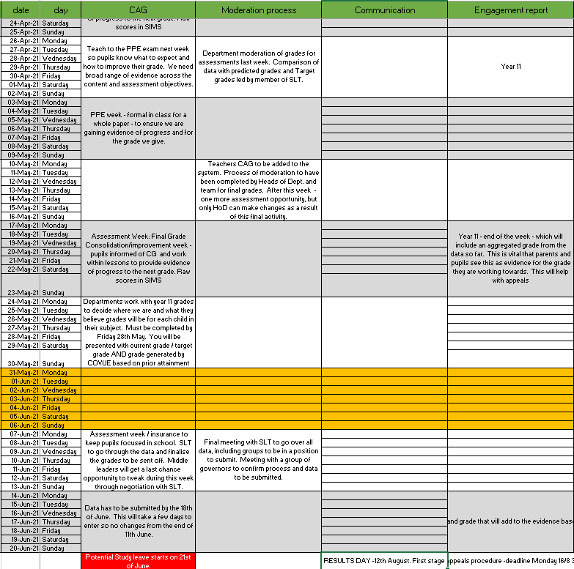

Newsletter to parents on 26th Feb 2021:
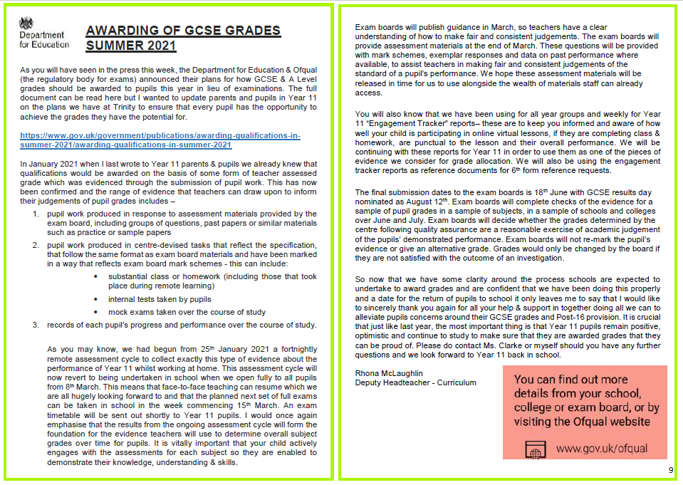
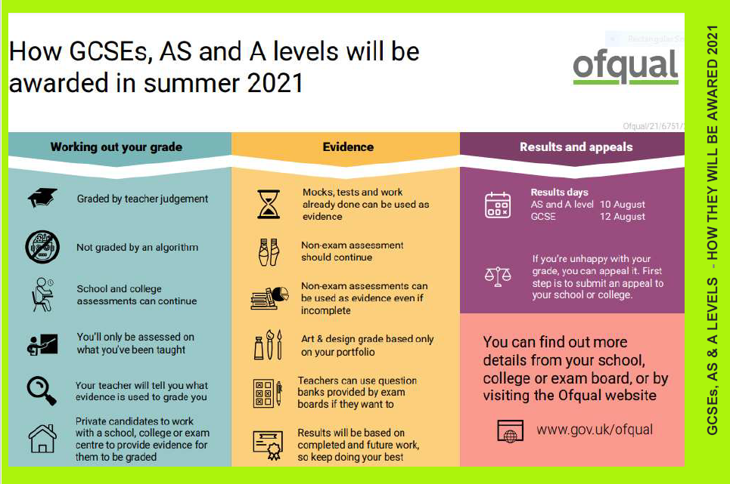
Dear Parents/Carers,
At the time of writing we are now in a position for this period of ‘online school’ to send you an engagement tracking report at the end of each week. This tracker will allow you to have an idea of your child’s level of engagement in each of their subjects on a weekly basis. For Year 11 these weekly trackers will form an important part of the collection of evidence for the awarding of GCSE grades and therefore pupils must be working to ensure that for all subjects they are achieving A & B.
At the end of each week the teachers will give your child a grade for engagement between A and D - the key to these grades is here:
Key for A-D Engagement Grades:
A | Has attended all lessons during the week on time and stayed throughout, participated fully in lessons with in-depth and thoughtful answers, produced work beyond expectation, completed all classwork and homework set to the very best of their ability.
B | Has attended all lessons during the week on time, participated well in lessons when invited, completed all classwork and homework well and on time.
C | Has not been present for entire lessons - either late to lesson, or left before the end. Minimal participation in lesson, classwork and homework not completed entirely or to their best of ability.
D | Has been absent from one or more lessons without a valid reason, has not participated in lesson as required, has not completed classwork or homework set, online behaviour is below expectation.
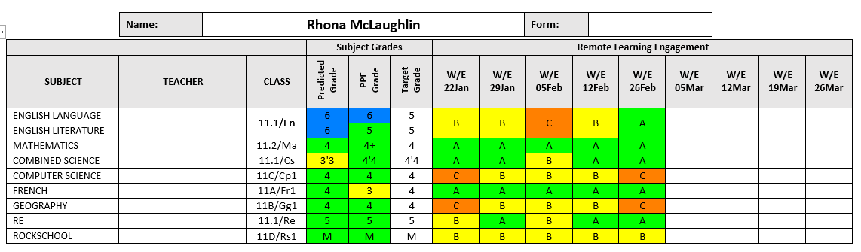
The pupils tracking sheet (example above) has been issued weekly, then moved to fortnightly, so parents and pupils are kept fully informed about work rate / motivation and where they are using internal school data. This data is not the final grade and will need to be moderated within departments and across the school. The final grade will not be given to pupils until the results day. Pupils are told this throughout their lessons and through assemblies.

Evidence of data tracking and decision making:
Below is an example from one subject how data was tracked in one spreadsheet and used alongside prior attainment of each individual, target grades and Trinity School’s historical attainment. Data was tracked and used in moderation & standardization procedures by middle leaders along with data analysts and the senior team. Trinity School’s data management services are supplied by an external company with whom we have an SLA & as a result this gives another layer of independent impartial help & support to examine the statistics objectively in line with recent school performance. Alongside this the mitigating circumstances reported by either pupils or/and parents information was used to help inform the final grade awarded. Pupils and parents in March were issued with direct sheets to provide evidence of circumstances that the school should potentially take into consideration when awarding grades.

Trinity Church of England School: Subject Evidence Base EXAMPLE
Subject |  | Exam board
Course code |  | Number in cohort
Content Coverage Summary - the assessment objectives for the course have been covered.
Students have completed a variety of A01/A02 questions from the components below [see content coverage mapping breakdown document].

Component 1: The study of religions: beliefs, teachings and practices

In relation to the specification all students for component 1 have covered:
- 3.1.2.1 Beliefs and teachings – Christianity
- 3.1.2.2 Practices- Christianity
- 3.1.5.1 Beliefs and teachings - Islam
- 3.1.5.2 Practices- Islam

This totals 100% of component one.

Component 2: Thematic studies
In relation to the specification all students for component 1 have covered:
• 3.2.1.1 Theme A: Relationships and families.
• 3.2.1.2 Theme B: Religion and life.
• 3.2.1.5 Theme E: Religion, crime and punishment.

This totals 75% of component one. One unit was not completed due to the covid pandemic.

Due to equal weighting of component one and two, all students have been taught 88% of the course, 7 of the 8 units in total have been covered in full and students have been assessed on a variety of topics within those units [see coverage mapping].

Types of assessment evidence collected
- End of year 9 formal assessment
- Year 10 2 x assessments
- Year 11 Mock November 2020
- Fortnightly assessments following whole school system including:
- Past paper questions
- Multiple choice questions to test knowledge acquisition
- student work produced in response to assessment materials provided by the exam board, including groups of questions, past papers or similar materials such as practice or sample papers
- non-exam assessment (NEA) work (often referred to as coursework), even if this has not been fully completed
- student work produced in centre-devised tasks that reflect the specification, that follow the same format as exam board materials and have been marked in a way that reflects exam board mark schemes – this can include:
  - substantial class or homework (including those that took place during remote learning)
  - internal tests taken by pupils
  - mock exams taken over the course of study
- records of a student’s capability and performance over the course of study in performance-based subjects such as music, drama and PE
- records of each student’s progress and performance over the course of study

Quality Assurance
How the department moderated the work across the school and across schools
- In addition to moderation we also standardise before we begin individual marking
- All assessments are then marked and moderated within the department – this is led by two exam markers one of which is a senior exam marker for AQA RE.
- Once moderation has occurred, the HOD will then quality assure the raw scores and any anomalies or concerns will be discussed with the class teacher.
- Only then will final marks and grades go onto SIMS.
Moderation is a regular feature of RE meets, diocese meetings, and contact with other heads of department. There is an online social media platform where RE HODs and teachers regularly moderate exam answers together which has further supported our robust moderation process.
How was this moderated across the school
See the whole school page demonstrating the Trinity approach.

Trinity

Taunton Road
Lee, London
SE12 8PD

Tel: 020 8852 3191
Fax: 020 8463 0201

Executive Headteacher :
Mr David Lucas BSc (Hons) MA NPQH
15th March 2021

Dear Parent/Carer,

I am writing to update you on the processes and plans we are currently working on for awarding GCSE grades to our YR. 11 pupils. As you will know from my other letters and the article in the school newsletter of 26th Feb (attached) the Department for Education & Ofqual have released and will continue to publish more guidance for schools and teachers on how the evidence for awarding grades should be gathered. As you know, from January 25th we began a fortnightly assessment cycle (remotely) which, in addition to the PPE grade from Nov/Dec 2020 has started to form the basis of the data we will use to calculate grades. We are carrying on this assessment cycle now we are back in school teaching face to face.

As I outlined to you before, we think it is important that we are as transparent with you and pupils as possible in terms of the evidence base we are drawing from and we want to make sure that all pupils are given every opportunity to produce the work of the standard that they are capable of. To that end I want to share with you and your child the departmental plans for these assessments – we want to make pupils aware of the overall content of what each subject assessment will cover therefore making it easier and more straightforward for them to effectively revise. Each individual teacher will also in class talk about upcoming assessments & where to focus revision to encourage and motivate pupils to achieve. This year grades are to be allocated by teachers on the evidence which reflects the standard the pupil is performing at over a period of time and we want this period of time to give the best chance of achieving to all our pupils.

Please do share the assessment cycle document with your child – copies will be given to them too so that they can see how every subject is using the assessment cycle to test pupils across the various topics and papers of their individual specifications.

We are continuing with the “Engagement Tracker” reports now we are back in school in order to keep you informed and aware of how well your child is participating in lessons, if they are completing class & homework, are punctual to the lesson and their overall performance. The report will also include the first initial grade we are able to give based on pupil performance in order that both you and they can see the progress they have made, the grade of work they have produced so far and most importantly a clear route for improvement should any of their grades be below what they want to achieve and need to score to move on with the next phase of their academic journey.

As part of the strategies we have for the success of all of our Yr. 11 pupils we will be continuing our programme of after school “Period 7” sessions on Thursdays but between now and the Easter holidays these sessions are especially targeted at specific pupils who need additional help and support in ensuring they have completed all the work set during lockdown. After our return on 19th April after the Easter holidays we will be offering to all Yr. 11 a menu of activities that they can choose from for Period 7 on Thursdays. These activities will include some of the below so that we are able to help Yr. 11 with not only their academic lives but also their mental & physical well-being.
- Mental Health Activities (Mental Health Team)
- Physical Health Activities (P.E.)
- Private Study space ( library)
- Activities for Higher Attaining pupils
- Preparation for interviews

We look forward to regular updates from the Department for Education in terms of the next steps and I would take the opportunity again to sincerely thank you again for all your help & support in these really hard times for our young people. The most important thing is that Yr. 11 pupils remain positive, optimistic and continue to study to make sure that they are awarded grades that they can be proud of.

Yours faithfully

Rhona McLaughlin
Deputy Headteacher

Pupil consent form:
Pupil Name in full: ________________________________________
I confirm that the work which I have submitted to be used as evidence for my teacher assessed grade is my own work. I have submitted all the work that I believe to be appropriate for Trinity School to use to evidence my teacher assessed grade for each subject with no omissions.

Signed: __________________________________________________________________ (pupil)

It is important that we make you aware of the work that will be used as evidence to grade your work. The final grade will be a moderated combination which will include all the information below. It will include:
- Tests carried out throughout the GCSE period (from the start of Yr. 9 until June 2021)
- PPE1 taken in school November 2020
- Fortnightly assessments that have been set from January 2021 until June 2021 – some completed remotely, during lessons and some in more formal exam conditions (e.g. PPE2 W/C 15/3/2021)
- Remote Engagement Tracker reports from January until June 2021
- Any other class or home assessment that has been carried out from January 2021
I understand that the work listed above will form the evidence base on which my grades will be awarded for my GCSE outcomes this academic year. I understand that I have the right to appeal the grade given if I am able to provide evidence to support my appeal challenge.
Signed: _________________________________________________________________________ (Pupil)

Mitigating circumstances for grade consideration:
If you feel there are specific circumstances which have had a detrimental impact on how you were able to perform please outline them here. These are things which you feel have impacted the way in which you were able to perform, compared to all pupils that have been affected by COVID 19. Please include any evidence that would back up your claim. Any reasonable mitigations may be taken into account when grades are awarded.
__________________________________________________________________________________________________________________________________________________________________________________________________________________________________________________________________________________________________________________________________________________________________________________________________________________________________________________________________________________________________________________________________________________________________________________________
Please continue on another sheet if you require this.
I agree that the information within this form is accurate to the best of my knowledge:

Signed: ________________________________________________________ (Pupil)
Date: __________________

Parent consent form:
Pupil Name in full: ________________________________________
I believe the work submitted by the pupil named above has been completed by themselves without any unfair additional help or individual support at home & at school. This work will be used as evidence to generate a grade and is therefore reflective of their ability at the time it was completed. I believe that all the work that could be used to evidence a teacher assessed grade for each subject has been submitted with no omissions.

Signed: _________________________________________ Parent name in full: _____________________________

It is important that the school makes you aware of the work that will be used as evidence to grade your child this academic year. The final grade will be a combination of all the information below and will not be given based on any single piece of work. It will include:
- Tests carried out throughout the GCSE period (from the start of Yr. 9 until June 2021)
- PPE1 taken in school November 2020
- Fortnightly assessments that have been set from January 2021 until June 2021 – some completed remotely, during lessons and some in more formal exam conditions (e.g. PPE2 W/C 15/3/2021)
- Remote Engagement Tracker reports from January until June 2021
- Any other class or home assessment that has been carried out from January 2021
I understand that the work listed above will form the evidence base on which my child’s grade will be awarded for their GCSE outcomes this academic year. I understand that I will be able to appeal the outcome after the results and should I wish to appeal any grades this would need to be substantiated with evidence.

Signed: __________________________________________________________________ (Parent)

Mitigating circumstances for grade consideration:
If you feel there are specific circumstances which have had a detrimental impact on how your child was able to perform please outline them here. These are things which you feel have impacted the way in which your child was able to perform, compared to all pupils that have been affected by COVID 19. Please include any evidence that would back up your claim. Any reasonable mitigations may be taken into account when grades are awarded.
__________________________________________________________________________________________________________________________________________________________________________________________________________________________________________________________________________________________________________________________________________________________________________________________________________________________________________________________________________________________________________________________________________________________________________________________
Please continue on another sheet if you require this.
I agree that the information within this form is accurate to the best of my knowledge:

Signed: ________________________________________________________ (Parent)
Date: __________________

Trinity

Taunton Road
Lee, London
SE12 8PD

Tel: 020 8852 3191
Fax: 020 8463 0201

Executive Headteacher :
Mr David Lucas BSc (Hons) MA NPQH
March 2021

Dear Parent/Carer,

I am writing to update you on the processes and plans we are currently working on for awarding GCSE grades to our Yr. 11 pupils. As you will know from my other letters, part of the process of awarding grades this year is that we want to make sure that all pupils & parents are clearly aware of the sources of evidence that we are using to draw upon. You will have received by post (& pupils have received one by hand) a packet of information which contained the details of the subject assessment cycles so that pupils are able to structure their revision for the fortnightly assessments. Enclosed with this letter is a “consent form” which I would ask that you read carefully, complete and sign and return to school with your child. A copy of this declaration will also be available on WeDuc & emailed to you. During Family Group Time your child will also be completing & signing a pupil version of this document. Family Group Leaders of Yr.11 will ensure that your child understands the document and will help them to complete it properly and be able to answer any questions they may have about it. We are asking all pupils and parents to complete the document as it is an important aspect of the guidance issued by the Department for Education in terms of being transparent around how we are awarding grades this year. This is a key document for us to hold in school on your behalf until Results Day on 12TH August 2021 and therefore I would ask that you return the completed form with your child as soon as possible.

Please do encourage your child to make good use of the assessment cycle information they have received, each subject has clearly laid out the topics and objectives of their specification and most importantly when these topics will be assessed so it should be invaluable for structuring revision and therefore a terrific aid to performing well in the assessments in school.

The report you will receive at the end of this term will include the first initial grade we are able to give based on pupil performance in order that both you and they can see the progress they have made, the grade of work they have produced so far and most importantly a clear route for improvement should any of their grades be below what they want to achieve and need to score to move on with the next phase of their academic journey.

We look forward to regular updates from the Department for Education in terms of the next steps and I would take the opportunity again to sincerely thank you again for all your help & support in these really hard times for our young people. The most important thing is that Yr. 11 pupils remain positive, optimistic and continue to study to make sure that they are awarded grades that they can be proud of.

Yours faithfully

Rhona McLaughlin
Deputy Headteacher

Trinity Church of England School – 2021
Appeals form 1: Initial review process – Admin/Technical error check
By completing this form you are asking the school to check they have entered the right grade. This process must be followed to enable you to then move to the next stage of the appeal which will go to the exam board.
Student name |  |  |  |  | Date of Birth
Parent name |  |  |  |  | Date appeal submitted
Subjects to review
Subject name |  | Grade given | Grade expected | Evidence for higher expected grade
General comments:

Signed by parent and pupil:

Office use
Date appeal received
Each grade given checked with school data base for evidence collected
Outcome given to parents along with appeal 2 form.
Notes
Signed: |  |  |  |  | Date

Trinity Church of England School – 2021
Appeals form 2: Request for Formal Appeal
By completing this form you are asking the school to make an appeal to the relevant exam board. The exam board will check that the school followed its own published processes and exam board requirements as well as reviewing the evidence used to form their judgment and providing a view as to whether the grade awarded was a reasonable exercise of academic judgment.
Pupil Full name |  | Date of birth
Parent name |  | Date formal appeal submitted
This document will be sent to the exam board along with the evidence you have provided below and:
- The first appeal documentation and outcome that the school checked the processes were followed correctly
- The whole school procedure document outlining how it awarded grades this academic year
- Subject procedure document – highlighting how they came about the grade in the specific subject area
- Evidence of remote engagement tracker reports with grades issued to parents from Jan-June 2021.
- Formal reports issued to parents with grades attached over the last 2 years.
- Data from the assessments as highlighted in the consent forms completed – showing the grades awarded throughout their time in KS4.
- Copy of pupil consent form – signed in March highlighting the process and evidence to be used
- Copy of parent consent form – signed in March highlighting the process and evidence to be used
Formal appeal with evidence [clear evidence of the grade you believe the pupil should get must be provided. Specific and consistent work at the grade you believe should be awarded, completed between January 2021 & May 2021 and certified to be the sole work of the pupil must be submitted for the exam board to consider]
Subject | Grade awarded by school |  | Grade the pupil / family feel they have evidence to provide
Evidence
Subject | Grade awarded by school |  | Grade the pupil / family feel they have evidence to provide
Evidence
Subject | Grade awarded by school |  | Grade the pupil / family feel they have evidence to provide
Evidence

Trinity Malpractice Policy for awarding grades in 2021

Trinity school always works closely with the JCQ and the awarding bodies to ensure any submitted work is an accurate reflection of our pupils’ ability. In 2021 we are all eager to ensure that we issue results which are a fair and accurate reflection of learners’ abilities. The integrity of the results are particularly dependent on robust procedures within schools and colleges. Our policy highlights the process we have used to issue the grades.
There may some instances where a few individuals fail to act appropriately in the conduct of the teacher assessed grade process. In these cases we will follow the JCQ official malpractice guidelines and investigate all allegations thoroughly.

Centres/centre staff
- The awarding bodies may investigate credible allegations that raise concerns about the failure to follow due procedures in the centre assessed grade process. Examples (for General and Vocational qualifications) include:
- A Head of Centre fails to submit the required declaration when approving and submitting their Teacher Assessment Grades.
- A failure by a centre to appropriately manage Conflicts of Interest (COIs) within a centre.
- Teacher Assessment Grades being released to learners (or their parents/carers) before the issue of results.
- If new exam entries are created for learners who had not intended to enter for June 2021 or if tier changes are made to gain an unfair advantage rather than as an accurate reflection of a learner’s ability.
- A failure to submit Teacher Assessment Grades and rank orders which honestly and fairly represent the grades that students have been achieving in school consistently over a period of time.. This might include situations in which centre staff have been unreasonably pressured into making changes to their Teacher Assessment Grade judgements or making such changes themselves without reasonable grounds.
- A failure to accurately report grades of completed units for vocational qualifications.

Learners
It is possible that some learners may attempt to influence their teachers’ judgements on their Teacher Assessment Grades. Learners might try to do this by submitting false evidence of performance or by applying pressure. The awarding bodies anticipate that the majority of such instances will be dealt with by the centre internally. However, if the learner’s behaviour continues then please inform the relevant awarding body using the JCQ form. The awarding bodies will contact your centre directly if we receive credible allegations that such pressure has been applied.
In all the scenarios listed above, as well as any others that have not been explicitly identified here, the JCQ Suspected malpractice policies and procedures 20120 continues to apply.

